Concurrent Enrollment/CAN Courses at DSU Kanab Center
Students from Valley and Kanab High School are taking advantage of the Dixie State University courses being taught in person and electronically at the new facility. Currently there are 97 students enrolled in 179 courses earning 568 college credits during the Spring 2020 semester, which is a 230 credit increase from the prior year. High school students in the Kane School district are taking more college credits than ever before and working toward industry recognized certificates. One certificated program that students are seeing great success is the Certified Nursing Assistant (CNA) where 11 students from Valley and Kanab receive instruction from Jennifer Harrington MSN, RN in person and over IVC during their regular school day. The district provides transportation for 4 students from Valley to attend the course and 7 students from Kanab are also enrolled in the course. We would like to thank Mrs. Harrington for her willingness to travel to Kanab as a Dixie College instructor to provide our students with the opportunity to earn their CNA while they are in high school. The CNA course is the first of many courses available at the new DSU Kanab Center located at Kanab High School. Also, thanks to our students for taking advantage of the concurrent enrollment and certificate programs in our district, and thanks to Mrs. Orton for working with the universities to facilitate the courses.
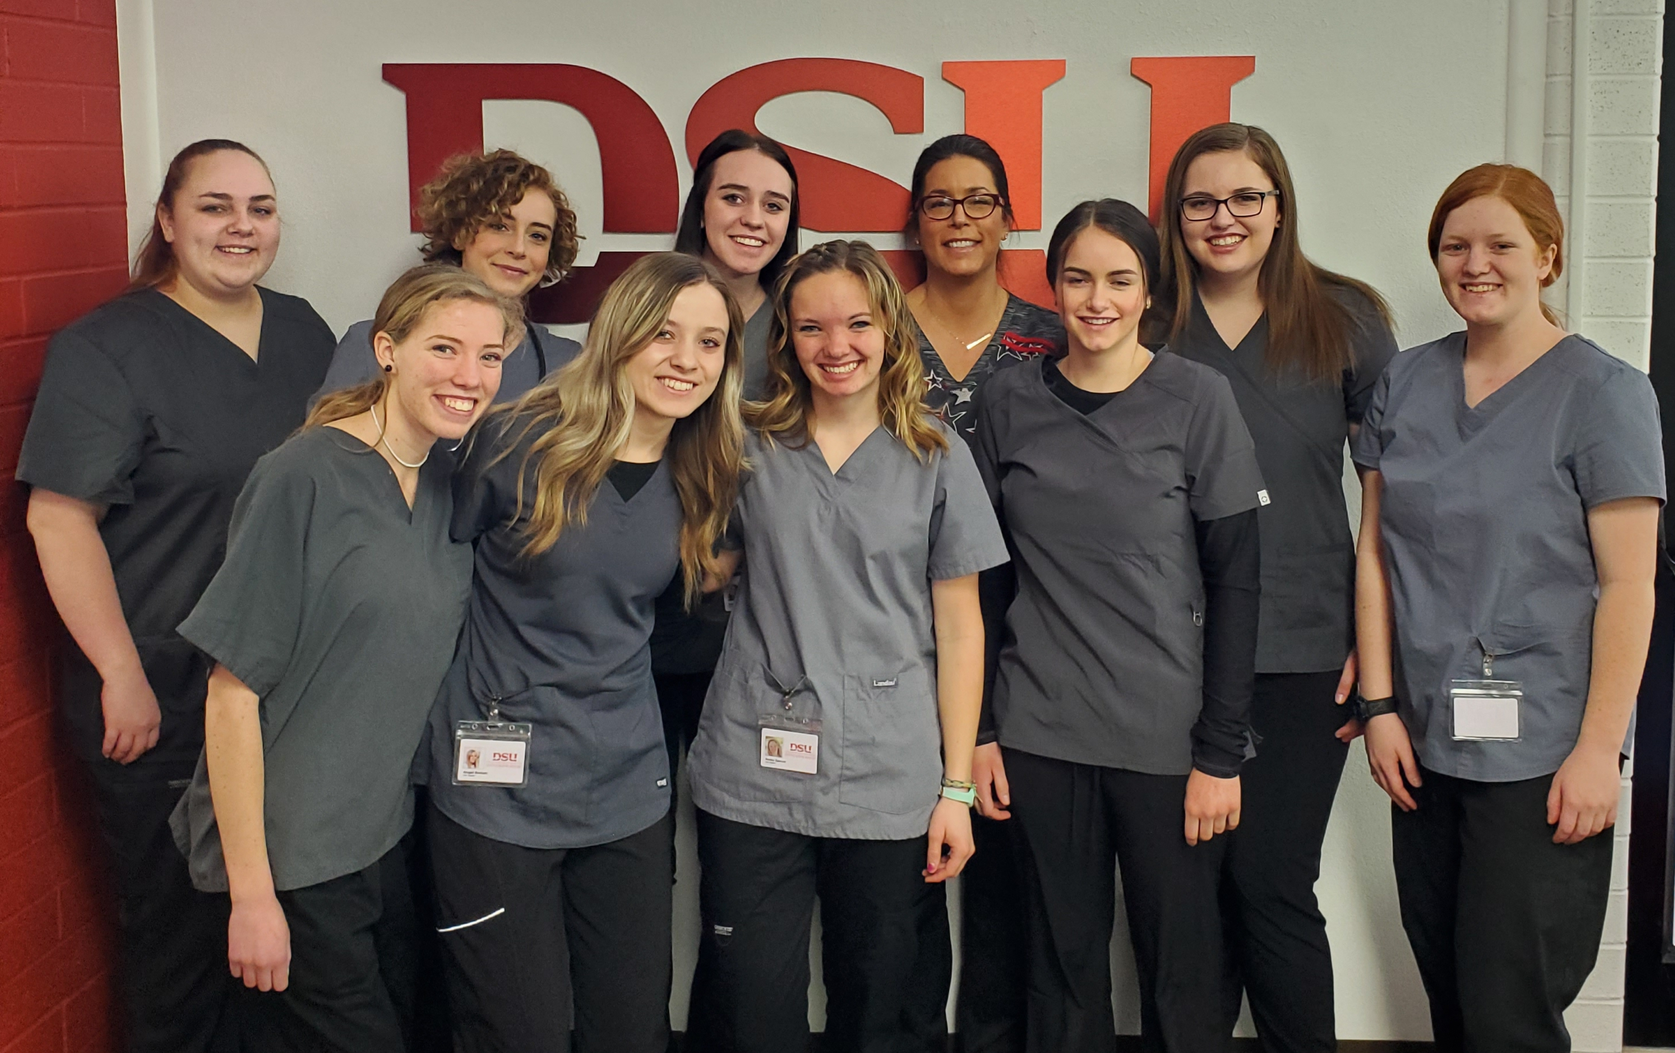
Ben Dalton
Superintendent
Kane School District

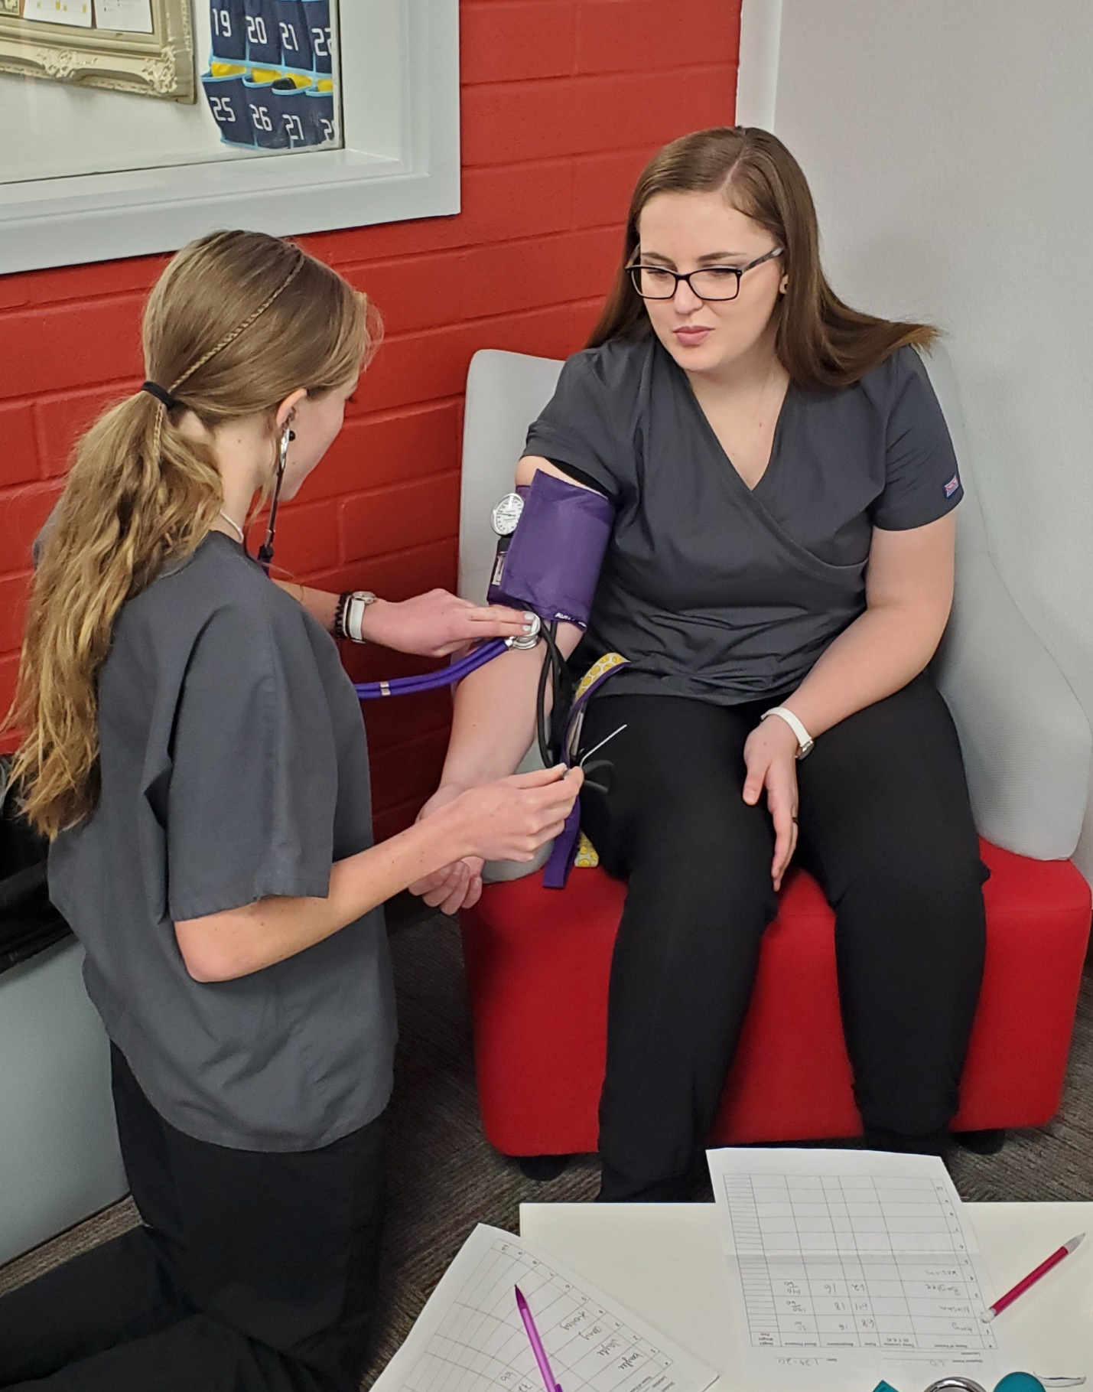

Front L-R, Keziah Palmer, Abigail Bonham, Kenley Spencer, Emily Rogers and Amy Cox. Back L-R, Jayde Heaton, Niesha Mognett, Baylee Ramsay, Instructor Jennifer Harrington and Lexie Dalton. Not pictured are Kayce Carman and Macee Hirschi.

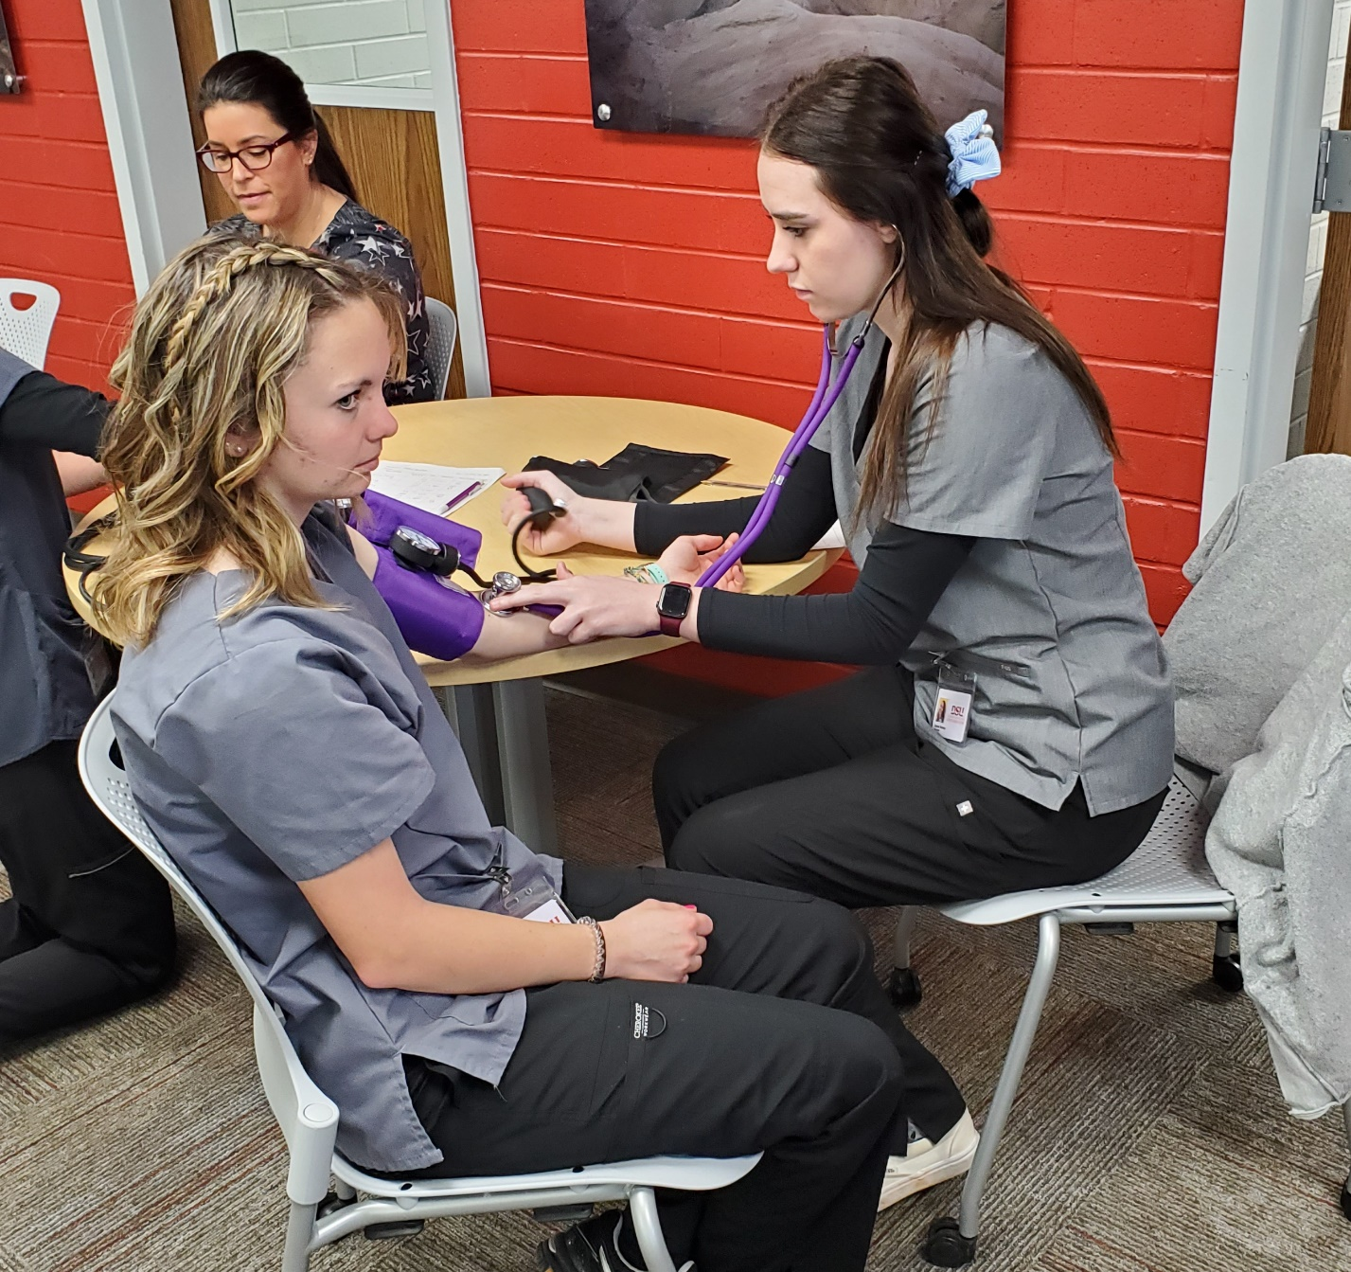

Keziah Palmer and Lexie Dalton
Kenley Spencer and Baylee Ramsay

